
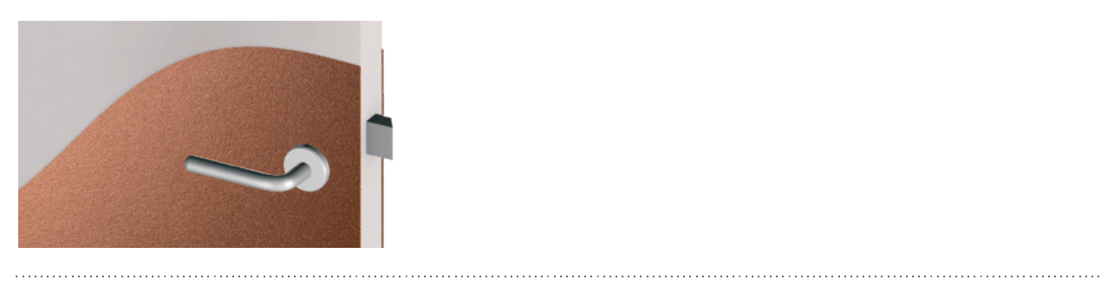

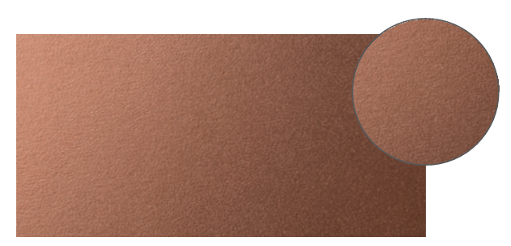

SPECIFICATION

HALF-HEIGHT DECORATIVE DOOR
DECOCHOC / DECOSMIC
PROTECTION AND COVERING PANELS – DECORATIVE CUT
- TWO COLOURS -

- Description: 2 mm thick half-height decorative two-colour door protection (Stratum, Cubic, Comma, Stairs, Rainbow masks as manufactured by SPM) from rigid and antibacterial PVC achieving Bs2d0 fire rating with solid colour and slightly textured surface. Width 930 or 1230 mm, height 1200 mm.
- Environment: no heavy metals and no substance potentially subjected to any REACH restriction are used in its manufacture, nor PBT/BPA. The calcium-zinc thermal stabilisation process is used. The emission level of volatile substance in inside air has been tested according to ISO 16000-6 and is very low (A+) according to the French regulation (23 March 2011 nr 2011-321 Decree and 19 April 2011 Order). 100% of the product are recyclable.
- Colour: selected by architect from manufacturer’s standard range.
- Installation method: glue as per manufacturer’s instructions.

